**1.Introduction Section:**

**1.1 Business Problem:** **In this study, we are going to open an Indian Restaurant in New York, US.**

The **City of New York**, is the [most populous city](https://en.wikipedia.org/wiki/List_of_United_States_cities_by_population) in the [United States](https://en.wikipedia.org/wiki/United_States).  The five boroughs – [Brooklyn](https://en.wikipedia.org/wiki/Brooklyn), [Queens](https://en.wikipedia.org/wiki/Queens), [Manhattan](https://en.wikipedia.org/wiki/Manhattan), [The Bronx](https://en.wikipedia.org/wiki/The_Bronx), and [Staten Island](https://en.wikipedia.org/wiki/Staten_Island) – were consolidated into a single city in 1898. The city and its metropolitan area constitute the premier gateway for legal [immigration to the United States](https://en.wikipedia.org/wiki/Immigration_to_the_United_States). According to the [2010 United States Census](https://en.wikipedia.org/wiki/2010_United_States_Census), the Asian Indian population in the United States grew from almost 1,678,765 in 2000 (0.6% of U.S. population) to 2,843,391 in 2010 (0.9% of U.S. population), a [growth rate of 69.37%](https://en.wikipedia.org/wiki/Demographics_of_Asian_Americans).**Indians in the New York City metropolitan region** constitute one of the largest and fastest growing ethnicities in the [New York City metropolitan area](https://en.wikipedia.org/wiki/New_York_City_metropolitan_area) of the United States. The New York City region is home to the largest [Indian American population among metropolitan areas](https://en.wikipedia.org/wiki/Indian_American#Demographics) by a significant margin, enumerating 711,174 uniracial individuals by the 2013-2017 [U.S. Census](https://en.wikipedia.org/wiki/U.S._Census_Bureau) [American Community Survey](https://en.wikipedia.org/wiki/American_Community_Survey) estimates.

**Table 1. Top Concentrations by Metropolitan Area for Immigrants from India, 2011-15**

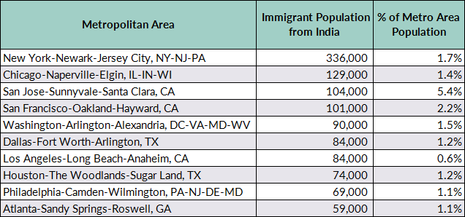

Source: MPI tabulation of data from the U.S. Census Bureau pooled 2011-15 ACS.

The above table information clearly shows that New York City has greater number of Indians than any other city in US, so it is a good idea to start the restaurant here. Of course, food and service are important to the success of a restaurant, but the location can be just as crucial. There need to be enough people who live in or pass through the area regularly to keep our business busy. This shows how important it is to start a restaurant in an area which is easily accessible and where you can attract your targeted audience easily. We analyse the neigborhoods in New York City to identify the most profitable area.

When looking for a restaurant location, consider who else is doing business in the neighborhood. Are there already half a dozen restaurants with the same concept as yours? Is the area busy or full of empty storefronts? Successful businesses attract other successful businesses.

**1.2 Target an audience:**

Why people would care about your problem or how your product can benefit them?

*No product without a customer. There is no film without a viewer.*

**This study will help and give more information to:**

* Indian peoples who wants to know about the neighbourhood Indian Restaurants.
* Business personnel who wants to invest or open an Indian Restaurant in New York City.
* Data scientists who wants to analyse the neighborhoods of New York City.